
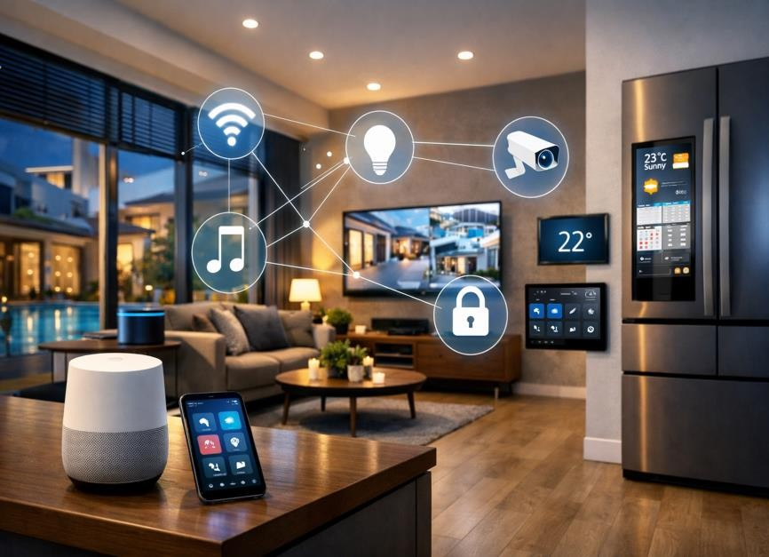

Smart Home
Internet of Things (IoT) Based Smart Living System
This project explores the integration of Internet of Things (IoT) technologies in smart homes to enhance comfort, security, and energy efficiency. It focuses on how connected devices communicate through a unified network to automate daily tasks, monitor environmental conditions, and provide intelligent
control over household systems.

Technical Project Report Project
Project Team

Mostafa Elsayed Elsayed Khodary Section 5
Mostafa Ahmed Sabry Abo Saif Section 5
Uosef Elsaid Elboraey Eissa Section 5
Ahmed hesham hamdy fathy Section 5
Mohamed abdo abo gotmas Section 4
Osama hany soltan Section 1
Layla Mostafa Yousef Abdelaziz El Agouz Section 4
Nora osama Abdallah Elgendy Section 5
Nada Ashraf Ali Muqallad Section 5
Manar Montaser Khamis Batarji Section 5

Academic Year 2025–2026
Supervised by : Dr. Samia Sorour

Table of Contents
__________________________________________________________________________

-1Abstract
-2Introduction
- Background
- Problem Statement
- Motivation
- Objectives
- Scope
3-Related Work
-4 System Analysis
- User Requirements
- Functional Requirements
- Non-Functional Requirements
- Stakeholders
- Use Case Descriptions
-5System Design
- System Architecture
- Database Design (Supabase)
- UML Class Diagram
- Sequence Diagram
- User Interface Design
- Database Design — Entity Relationship Model
-6Implementation
- Technologies Used
- Module Descriptions
- Core Algorithms
- Database Implementation Logic
7-Results and Discussion

-8Future Work
9-Challenges

10-Project Life Cycle
11-Conclusion
12-References
13-Acknowledgment
🧾1. Abstract
This project introduces an IoT-based Smart Home System that integrates six core sensors — DHT11 (temperature & humidity), MQ2 (gas detection), Soil Moisture, Rain, PIR (motion), and Ultrasonic — to provide comprehensive monitoring of the home environment. Sensor data is collected by Arduino, while ESP32 functions as the central controller, managing high-voltage devices through a Relay Module (220V) and enabling communication via the lightweight MQTT Protocol.
Unlike conventional smart home solutions, this system leverages Supabase as the cloud backend, offering secure authentication, scalable data storage, and real-time synchronization with built-in Row Level Security (RLS). A Flutter mobile application serves as the user interface, allowing seamless monitoring, instant alerts, and manual device control.
The system enhances safety (gas leakage and motion detection), efficiency (smart irrigation and energy optimization), and comfort (automated climate and lighting control). Furthermore, by continuously recording sensor data, the project lays the foundation for predictive analytics, enabling anomaly detection and intelligent decision-making that transforms the home into a truly data-driven environment.
2. Introduction
Background
The rapid growth of the Internet of Things (IoT) has transformed traditional living spaces into intelligent environments where devices communicate seamlessly through the internet. Smart homes represent one of the most impactful applications of IoT, offering automation of appliances, environmental monitoring, and remote access. By integrating sensors, controllers, and cloud platforms, smart homes enhance convenience, safety, and energy efficiency.
This project builds upon these foundations by designing a Smart Home IoT System that not only automates household devices but also incorporates advanced monitoring of environmental parameters such as temperature, humidity, gas levels, soil moisture, rainfall, and motion detection. The system leverages Arduino for sensor data acquisition and ESP32 as the central controller, supported by Supabase for secure cloud storage and real-time synchronization.

Problem Statement
Despite the growing adoption of smart technologies, several challenges remain:
- Manual control of home devices is inefficient and prone to human error.
- Traditional irrigation methods waste significant amounts of water due to lack of soil monitoring.
- Energy consumption is not optimized, leading to unnecessary costs and environmental impact.
- Safety risks such as gas leaks or unauthorized motion detection often go unnoticed without automated alerts.
Motivation
The motivation behind this project is to bridge the gap between conventional smart home systems and data-driven intelligent environments. By integrating IoT hardware with Supabase and applying Big Data analytics, the system moves beyond simple automation to predictive control and anomaly detection. This ensures proactive responses to environmental changes, improved resource management, and enhanced user safety.
Objectives
- Automate home appliances using sensor-driven logic and relay modules.
- Monitor soil moisture and rainfall to enable smart irrigation and conserve water.
- Enable remote control of devices through a Flutter mobile application connected to Supabase.
- Enhance safety by detecting gas leaks and unauthorized motion, triggering instant alerts.
- Reduce human effort while improving energy efficiency through intelligent decision-making.
Scope
The scope of this project covers:
- Hardware Layer: Arduino for sensor data collection, ESP32 for device control, relay modules for high-voltage appliances, and servo motors for door/window automation.
- Cloud Layer: Supabase for authentication, secure data storage, and real-time synchronization with Row Level Security (RLS).
- Application Layer: A Flutter-based mobile app providing dashboards, alerts, and manual control options.

3. Related Work

Previous smart home projects often relied on Firebase or local servers. This project introduces Supabase for secure, scalable, and real-time data handling, with Row Level Security (RLS) for safe multi-user access.

4. System Analysis

User Requirements

Real-time monitoring.

Remote device control.

Alerts for gas, motion, rain.

Functional Requirements

Sensor data collection.

Auto/manual control.

Password-protected door.

Non-Functional Requirements

Reliable WiFi connectivity.

Secure data handling via Supabase.

Low latency.

Stakeholders

Users, developers, supervisors.

Use Cases

Voice Command

Control Devices

View System Response

5. System Design

System Architecture

The proposed Smart Home IoT System is designed using a three-layer architecture that ensures modularity, scalability, and real-time responsiveness. Each layer plays a distinct role in the overall functionality of the system.

🟦 1. Hardware Layer (Arduino + ESP32)

This layer represents the physical infrastructure of the smart home.

Arduino (Data Acquisition Unit):

Responsible for collecting raw data from six sensors:

DHT11 → Temperature & Humidity.

MQ2 → Gas detection (smoke, LPG, propane).

Soil Moisture Sensor → Irrigation monitoring.

Rain Sensor → Rainfall detection.

PIR Sensor → Motion detection.

Ultrasonic Sensor → Distance measurement (security/level monitoring).

Arduino processes sensor signals and transmits them via Serial Communication to ESP32.

ESP32 (Central Controller):

Acts as the brain of the system, receiving sensor data from Arduino.

Controls high-voltage devices (Lamp, Fan, Pump, Buzzer) via Relay Module (220V).

Operates Servo Motors for door and window automation.

Provides WiFi connectivity and communicates with the cloud using MQTT Protocol.

✅ Key Role: Hardware ensures real-time sensing and immediate actuation of devices.

🟦 2. Cloud Layer (Supabase + MQTT)

This layer provides data management, synchronization, and security.

MQTT Broker (HiveMQ):

Lightweight publish/subscribe protocol for IoT communication.

ESP32 publishes sensor data to topics like home/sensors/data.

Mobile app subscribes to topics for real-time updates.

Control commands (e.g., home/control/lamp) are sent from the app to ESP32.

Supabase (Cloud Backend):

Provides authentication (user login/signup).

Stores sensor readings in structured tables (sensors, devices, users).

Implements Row Level Security (RLS) to protect user data.

Enables real-time synchronization between devices and mobile app.

Acts as a scalable database for Big Data analytics (pattern recognition, anomaly detection).

✅ Key Role: Cloud ensures secure data storage, real-time communication, and predictive analytics.

🟦 3. Application Layer (Flutter Mobile App)

This layer serves as the user interface for monitoring and control.

Dashboard: Displays real-time sensor readings (temperature, gas, soil, rain, motion, distance).

Control Panel: Allows manual control of devices (lamp, pump, fan, door, window).

Notifications: Alerts users about abnormal conditions (gas leak, rain, motion detection).

Big Data Page: Visualizes historical sensor data and provides insights for predictive automation.

Chat/Voice Assistant (Future Work): Enables natural language commands for device control.

✅ Key Role: Application provides user-friendly interaction, remote access, and visualization of system data.

🟩 Integration Flow

Sensors → Arduino → ESP32 (data acquisition).

ESP32 → MQTT Broker → Supabase (data transmission & storage).

Supabase → Flutter App (real-time monitoring & control).

User commands → Flutter App → MQTT → ESP32 → Relays/Servos (device actuation).

🟦 Advantages of the Architecture

Modularity: Each layer is independent and can be upgraded separately.

Scalability: Supabase allows adding more sensors or devices without redesigning the system.

Security: RLS policies in Supabase protect user-specific data.

Efficiency: MQTT ensures lightweight, fast communication even on low-bandwidth networks.

User Experience: Flutter app provides a modern, responsive interface.

Database Design (Supabase)

The system utilizes Supabase (PostgreSQL) for structured data storage. The database schema is designed for high-performance relational queries and real-time synchronization

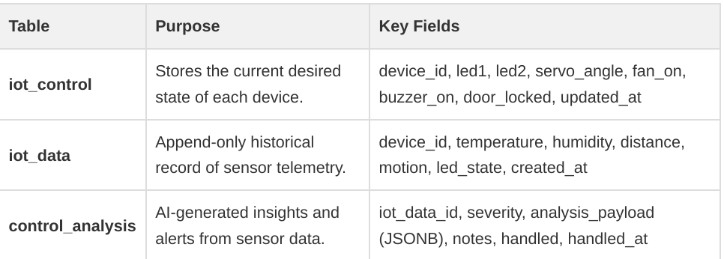

UML Class Diagram

The following diagram illustrates the data entities and their relationships within the Supabase ecosystem:
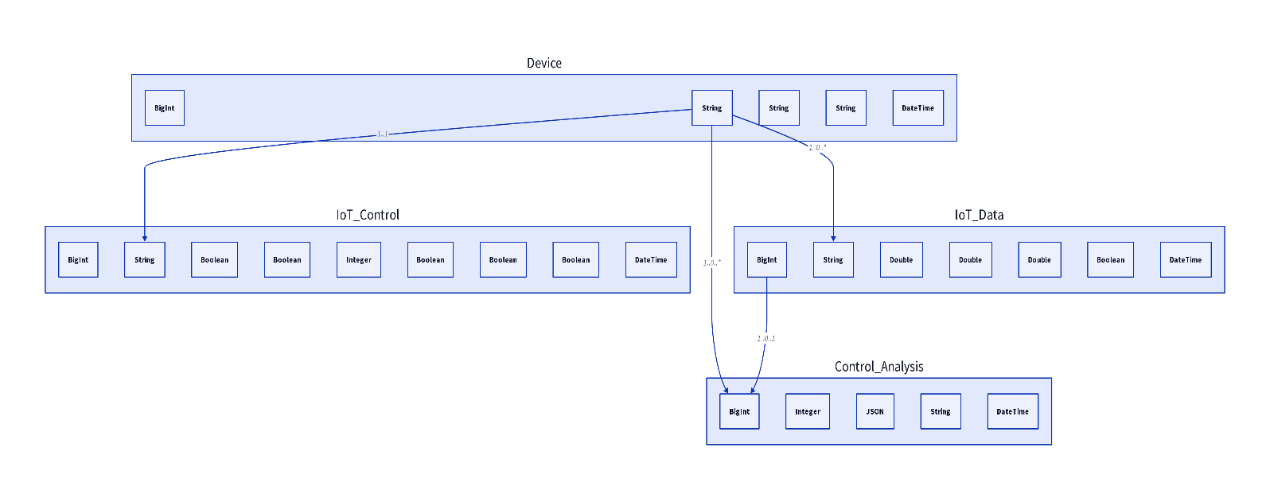

Sequence Diagram

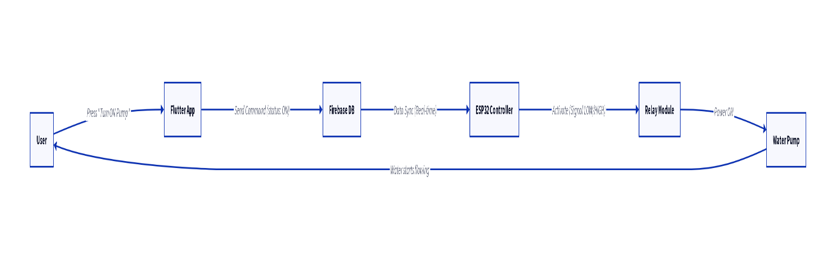
The following diagram illustrates the scenario of turning ON the water pump via the app:

UI Design

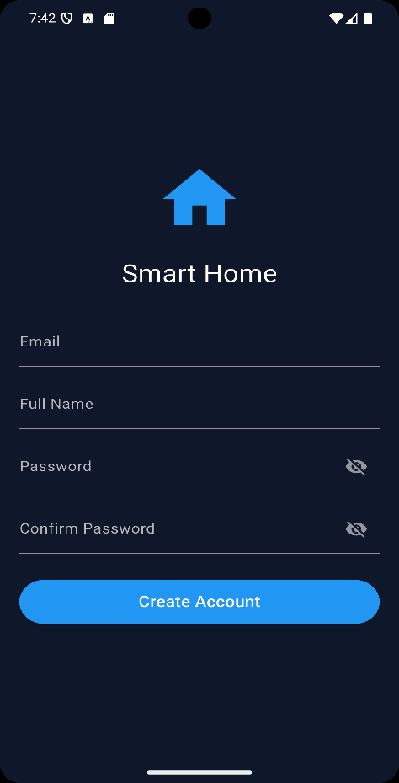
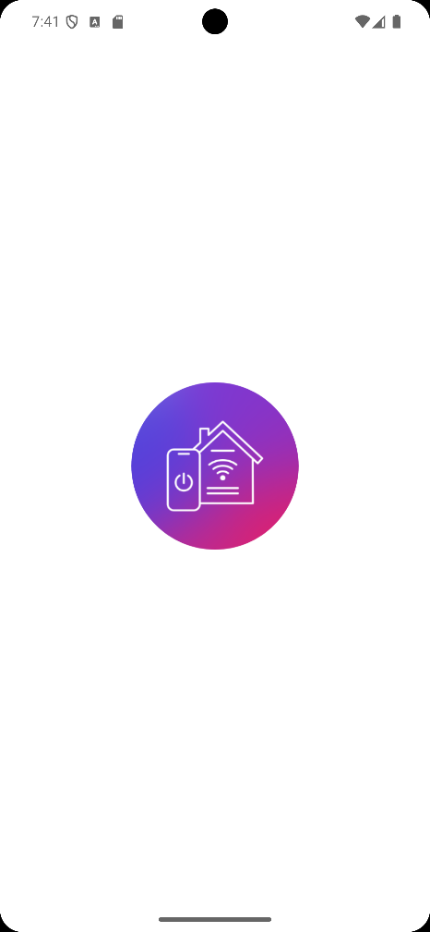

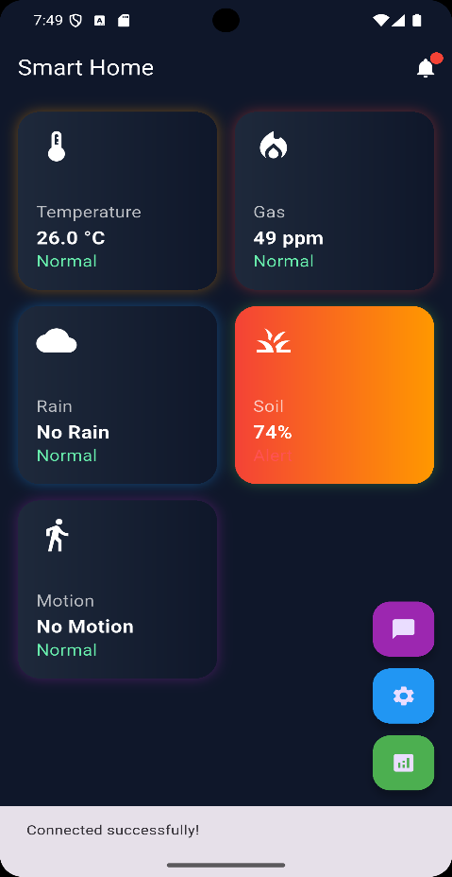
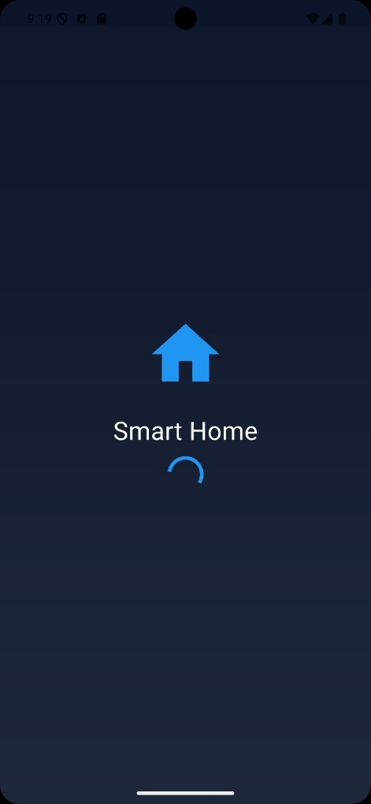
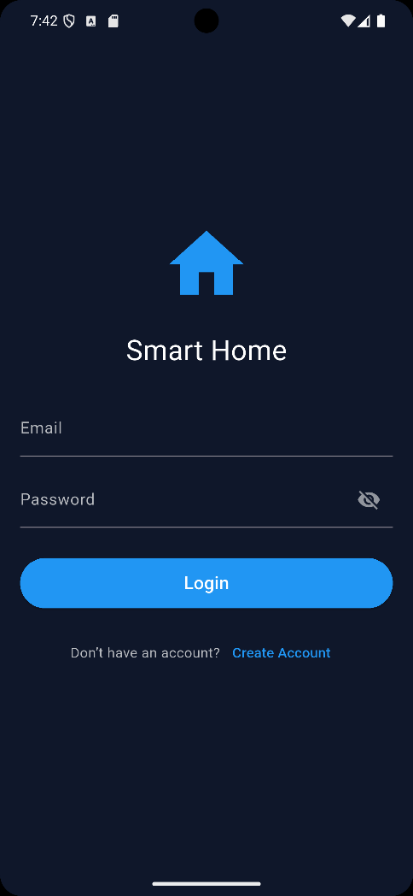
Flutter screens:
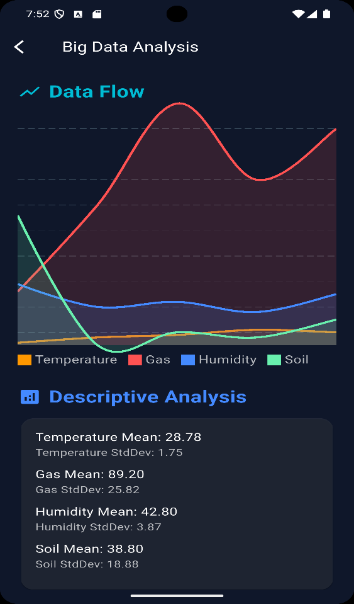
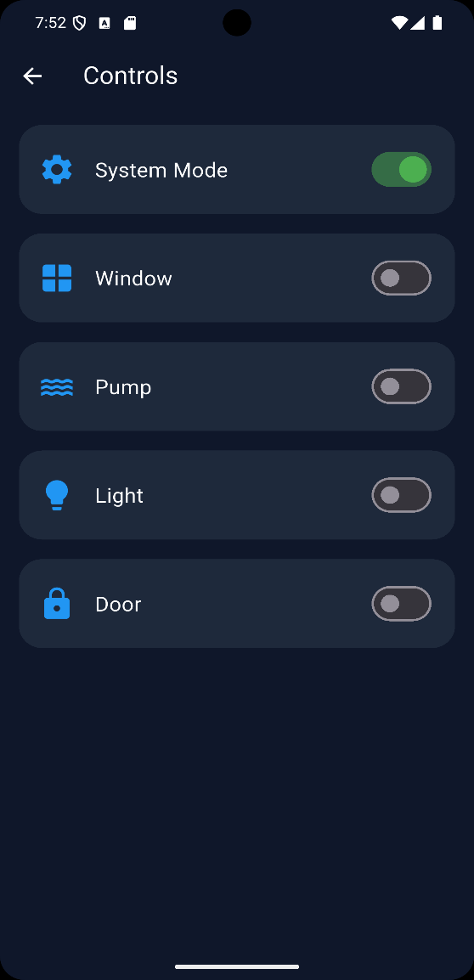
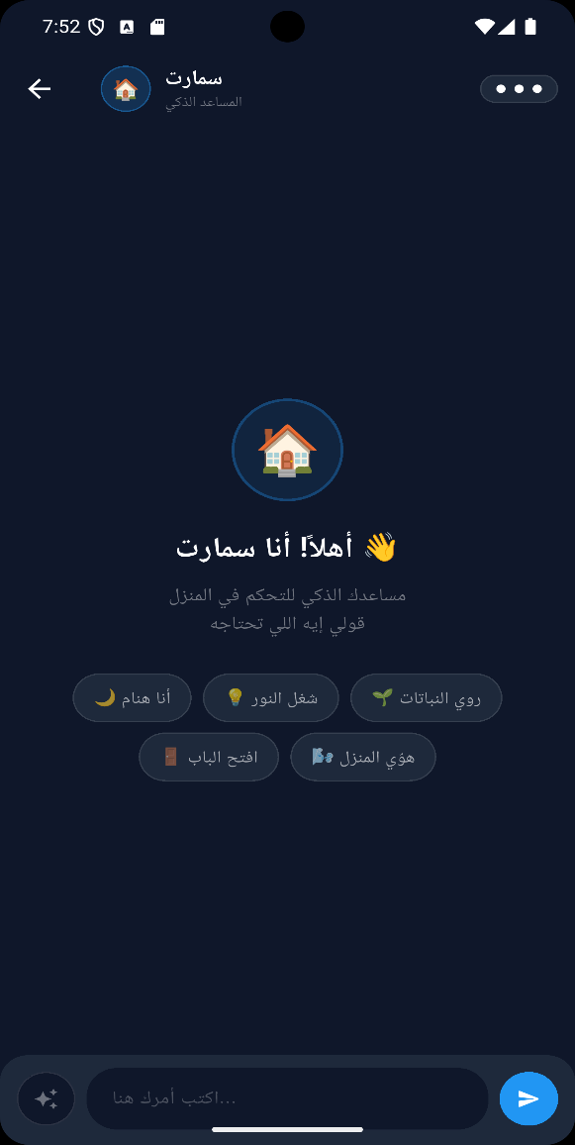
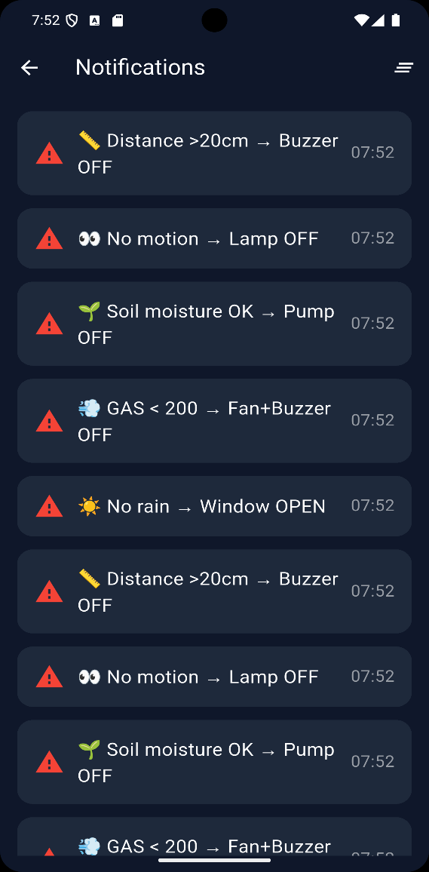

ER Diagram
Entities
- User
  - Attributes: user_id (PK), name, email
  - Represents each registered system user.
- Device
  - Attributes: device_id (PK), name, status, user_id (FK)
  - Represents smart home devices (lamp, pump, fan, window, door).
  - Linked to the user who owns or controls the device.
- Sensor
  - Attributes: sensor_id (PK), type, value, device_id (FK)
  - Represents IoT sensors (DHT11, MQ2, Soil Moisture, Rain, PIR, Ultrasonic).
  - Each sensor is associated with a specific device.
- SoilData
  - Attributes: soil_id (PK), moisture, timestamp, sensor_id (FK)
  - Represents historical soil moisture readings for irrigation analysis.
  - Linked to the sensor that collected the data.
Relationships
- User → Device (1:M) One user can own multiple devices, but each device belongs to a single user.
- Device → Sensor (1:M) Each device can have multiple sensors attached, but each sensor is linked to one device.
- Sensor → SoilData (1:M) A sensor can generate multiple soil moisture readings over time, but each reading belongs to one sensor.
ER Model Summary
This design ensures:
- Scalability: More devices and sensors can be added per user without restructuring.
- Data Integrity: Foreign keys enforce ownership and linkage between users, devices, and sensors.
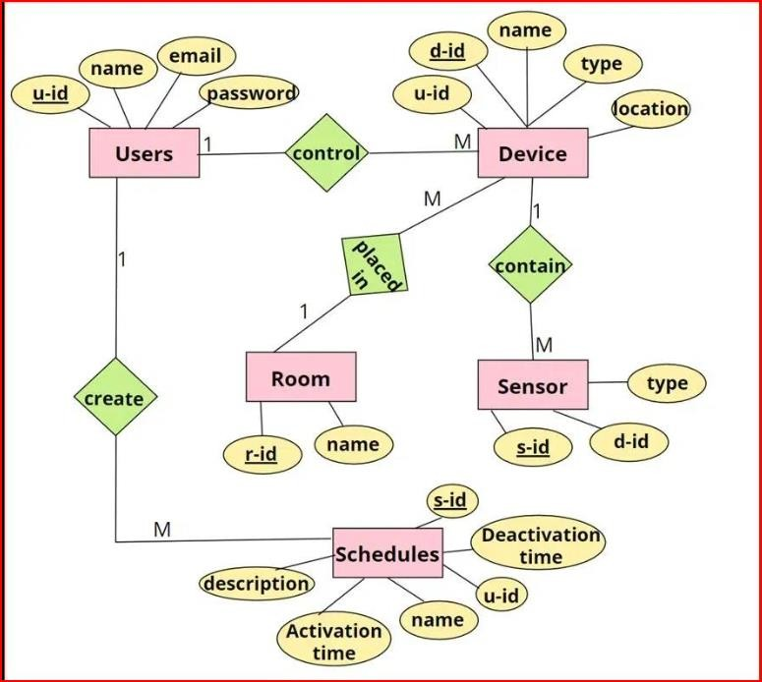
- Analytics Support: SoilData provides historical records for Big Data analysis, enabling predictive irrigation and anomaly detection.

📱6. Implementation
Technologies Used

Arduino IDE (C++) — programming the Arduino for sensor data acquisition.

ESP32 — central controller, responsible for WiFi connectivity and device management.

MQTT Protocol — lightweight publish/subscribe communication between ESP32 and the cloud.

Flutter (Dart) — mobile application development for monitoring and control.

Supabase — cloud backend providing authentication, secure data storage, and real-time synchronization with Row Level Security (RLS).

Modules

Mobile Application (Flutter): Provides a user-friendly interface for real-time monitoring, manual control, and notifications.

Cloud Backend (Supabase + MQTT Broker): Manages sensor data, device states, and user authentication while enabling real-time communication.

Hardware Control (Arduino + ESP32): Arduino collects sensor readings, ESP32 processes them, and actuates devices via relays and servos.

Core Algorithms

Smart Logic (Auto Mode): Automated decision-making based on sensor thresholds (e.g., activating irrigation when soil moisture is low).

Password-Protected Door: Ensures secure access by requiring a correct password before unlocking, with alerts for incorrect attempts.

Sensor Polling: Continuous acquisition of sensor data, transmitted to Supabase for storage and analysis.

Database Logic (Supabase)

iot_data — stores sensor telemetry (temperature, humidity, gas, soil, rain, motion, distance).

iot_control — stores device states (lamp, pump, fan, window, door).

7. Results and Discussion

Real-Time Monitoring: Sensor readings were successfully stored in Supabase and synchronized with the mobile app.

Automation vs Manual Control: Auto Mode reduced human intervention and optimized device usage compared to manual control.

Irrigation Efficiency: Soil moisture and rain sensors significantly reduced water waste by enabling smart irrigation.

Alerts: Gas leaks, rainfall, and unauthorized motion were detected and triggered timely notifications.

Scalability: The architecture proved capable of supporting additional sensors and devices without redesign.

8. Future Work

Voice Control — integration with natural language assistants for hands-free operation.

Computer Vision — camera-based recognition for enhanced security and automation.

AI Predictive Automation — machine learning models to predict user behavior and optimize energy usage.

Improved UI/UX — refining the Flutter app for better usability and visual appeal.

Integration with Smart Assistants — compatibility with Alexa or Google Assistant for broader ecosystem support.

9. Challenges

Developing and deploying the Smart Home IoT System involved several technical and operational challenges:

WiFi Connectivity Issues Maintaining a stable connection between ESP32, MQTT broker, and Supabase was critical. Network fluctuations caused delays in data transmission and device control.

Sensor Calibration Ensuring accurate readings from sensors (e.g., MQ2 gas sensor, soil moisture sensor) required calibration against environmental conditions, which was time-consuming and error-prone.

Real-Time Synchronization Achieving seamless synchronization between hardware, cloud, and mobile app demanded efficient data handling and minimized latency.

Integration Complexity Combining multiple technologies (Arduino, ESP32, MQTT, Supabase, Flutter) introduced compatibility issues and required careful design to ensure smooth interoperability.

10. Project Life Cycle

The development process followed a structured life cycle to ensure systematic progress and quality assurance:

Requirement Analysis Identifying user needs, functional requirements (automation, alerts, irrigation), and non-functional requirements (security, scalability, low latency).

System Design Creating the architecture with three layers (Hardware, Cloud, Application), defining database schema in Supabase, and designing the mobile app UI.

Implementation Programming Arduino for sensor data acquisition, ESP32 for device control and MQTT communication, and Flutter for the mobile interface.

Testing Verifying sensor accuracy, device actuation, cloud synchronization, and mobile app responsiveness under different scenarios.

Deployment Deploying the system in a real environment, connecting devices to Supabase, and enabling user access through the mobile app.

Maintenance & Enhancements Continuous monitoring, bug fixing, sensor recalibration, and iterative improvements such as adding new features (voice control, AI-based automation).

11. Conclusion

The Smart Home IoT System demonstrates how IoT combined with Supabase can transform domestic environments into intelligent, data-driven ecosystems. By integrating Arduino, ESP32, and MQTT with Supabase, the system achieves real-time automation, secure data management, and predictive control.

Beyond simple automation, the project establishes a foundation for Big Data analytics, enabling anomaly detection, behavioral insights, and proactive decision-making. This positions the system as a scalable and future-ready solution for modern smart homes.

12. References

Supabase Documentation

Flutter Documentation

Arduino Official Website

ESP32 Documentation

MQTT Protocol Specification

IoT Security Best Practices

13-🔗 Useful Links

GitHub Repository mailto:https://github.com/MostafaAhmedSabry/SmartHome.git

Supabase Project
mailto:https://supabase.com/dashboard/project/gprhgkgxcdefzxffclhi/editor/17652

Google Drive

mailto:https://drive.google.com/drive/folders/1HI9k9hk1Hra-z8FZEgY7PR735-GgkXsr?usp=sharing

14. Acknowledgment

Special thanks to Dr. Samia Sorour for her continuous guidance, valuable feedback, and encouragement throughout the development of this project. Her expertise was essential in shaping the concept and ensuring successful implementation.

